**Online Banking System**

**Description:**

The objective of this project is to maintain the accounts like saving account, withdrawing, depositing money and applying loan to the user. Bank provides account number to the customer for dealing transactions in the bank. At first a user registers himself/herself as customer. After that account can be opened. A customer can open more than one account.

**Users:**

• Accountant

• Customer

**Roles of Accountant are:**

• Login using his/her username and password

• Adding new account for customer

• Editing already available account

• Removing the account by using account number

• Viewing particular account details by giving account number

• Viewing all the account details

• Taking care of deposit and withdrawal operations

**Roles of Customer are:**

• Login using his/her username and password

• Transfer the money from his account to other account

• Checking the transaction history

**Tech stacks:**

• Java

• JDBC

• SQL

**Tools Used:**

• STS

• Mysql

**ER Diagram:**

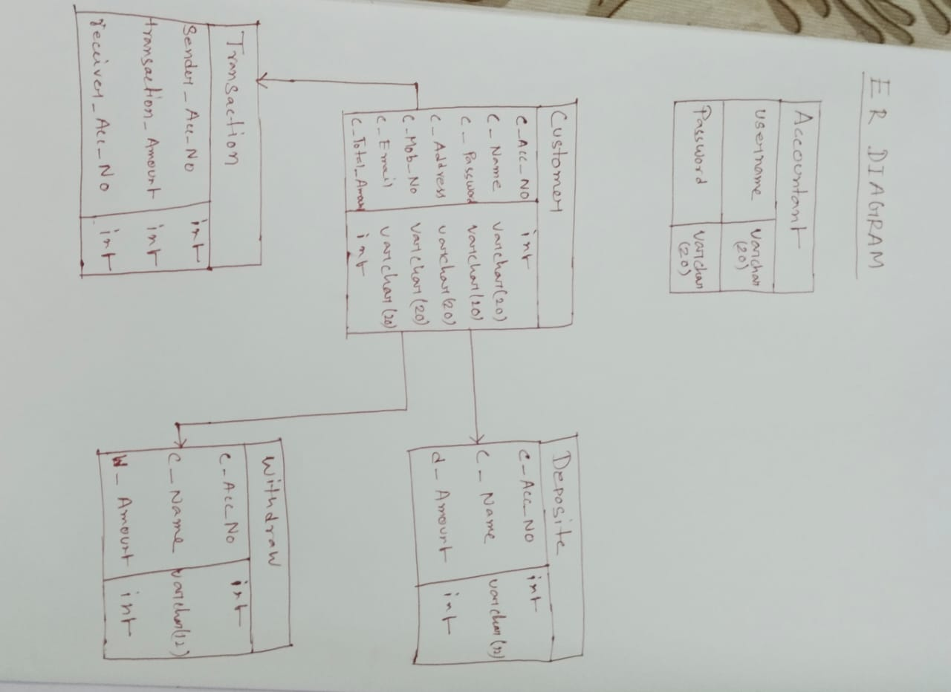

**Workflow:**

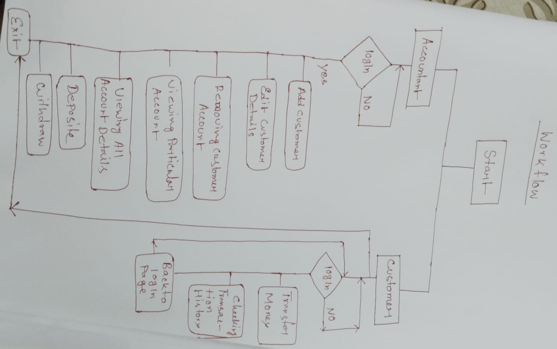

**Thanks**